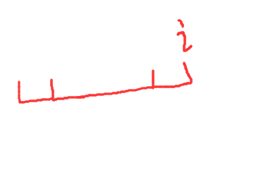
先反转一下字符串，然后就是这样，减去前缀后缀长度，就是当前循环结的长度，i是总出现长度。。为了这题去学了kmp
#include<bits/stdc++.h>
#define ll long long
using namespace std;
const int maxn=1e7+9;
char str[maxn];
int nextt[maxn];
void KMP(char *x,int *nextt)
{
nextt[0]=-1; nextt[1]=0;
int len=strlen(x);
int i=1,j=0;
while(i<len&&j<len)
{
if(j==-1||x[i]==x[j]) nextt[++i]=++j;
else j=nextt[j];
}
}
int main()
{
ll a,b;
while(~scanf("%lld %lld",&a,&b))
{
string s;
cin>>s;
reverse(s.begin(),s.end());
int cnt=0;
for(int i=0;i<s.length();i++)
{
if(s[i]=='.') break;
str[cnt++]=s[i];
}
KMP(str,nextt);
ll ans=a-b;
for(int i=1;i<cnt;i++)
{
ans=max(ans,a*(i+1)-b*(i+1-nextt[i+1]));
}
printf("%lld\n",ans);
}
return 0;
}

